A PROJECT REPORT

on

“HOUSEZ”

Submitted to

KIIT Deemed to be University

In Partial Fulfillment of the Requirement for the Award of

BACHELOR’S DEGREE IN

INFORMATION TECHNOLOGY

BY

PUSKAL MUKHERJEE
SAIKAT DAS
RIYA RANI MANDAL

1906345
1906355
1906493

UNDER THE GUIDANCE OF

Dr. RINA KUMARI


SCHOOL OF COMPUTER ENGINEERING

KALINGA INSTITUTE OF INDUSTRIAL TECHNOLOGY

BHUBANESWAR, ODISHA - 751024

Nov 2022

A PROJECT REPORT

on

“Housez”

Submitted to

KIIT Deemed to be University

In Partial Fulfillment of the Requirement for the Award of

BACHELOR’S DEGREE IN INFORMATION TECHNOLOGY

BY

PUSKAL MUKHERJEE
SAIKAT DAS
RIYA RANI MANDAL

1906345
1906355
1906493

UNDER THE GUIDANCE OF

Dr. RINA KUMARI

SCHOOL OF COMPUTER ENGINEERING

KALINGA INSTITUTE OF INDUSTRIAL TECHNOLOGY

BHUBANESWAE, ODISHA -751024

Dec 2022

KIIT Deemed to be University

School of Computer Engineering
Bhubaneswar, ODISHA 751024

CERTIFICATE

This is certify that the project entitled

“HOUSEZ”

submitted by

PUSKAL MUKHERJEE
SAIKAT DAS
RIYA RANI MANDAL

1906345
1906355
1906493

is a record of bonafide work carried out by them, in the partial fulfilment of the requirement for the award of Degree of Bachelor of Engineering (Information Technology) at KIIT Deemed to be university, Bhubaneswar. This work is done during year 2022-2023, under our guidance.

Date: 28/11 /2022

(Dr. Rina Kumari)
Project Mentor

Acknowledgements

We are profoundly grateful to Dr. Rina Kumari for her expert guidance and continuous encouragement throughout to see that this project rights its target since its commencement to its completion. Her kindness, dedication, hard work, and attention to detail have been a great inspiration to me. My heartfelt thanks to you for the unlimited support and patience shown to us.

SAIKAT DAS

ABSTRACT

We propose to implement a house price prediction model of Bangalore, India. It's a Machine Learning model which integrates Data Science and Web Development. We have deployed the ml model instance on Flask & hosted on Render. Housing prices fluctuate on a daily basis and are sometimes exaggerated rather than based on worth.
The major focus of this project is on predicting home prices using genuine factors. Here, we intend to base an evaluation on every basic criterion that is taken into account when establishing the pricing.
The client side is made using React.js & connected to ml-model using axios & hence a full-stack application is created.

Keywords: Machine Learning, Flask, React JS, Render, Netlify

Contents

1 | Introduction |  |  | 1
2 | Basic Concepts |  |  | 2
 | 2.1 | Machine Learning (ML) |  | 2
 | 2.2 | Flask |  | 2
 | 2.3 | React JS |  | 2
3 | Problem Statement / Requirement Specifications |  |  | 3
 | 3.1 | Project Planning |  | 3
 | 3.2 | System Design |  | 3
 |  | 3.2.1 | Design Constraints | 3
4 | Implementation |  |  | 4
 | 4.1 | Methodology / Proposal |  | 4
 | 4.2 | Testing / Verification Plan |  | 4
 | 4.3 | Dataset |  | 4
 | 4.4 | Screenshots |  | 5-6
5 | Standard Adopted |  |  | 7
 | 5.1 | Design Standards |  | 7
 | 5.2 | Coding Standards |  | 7
6 | Conclusion and Future Scope |  |  | 8
 | 6.1 | Conclusion |  | 8
 | 6.2 | Future Scope |  | 8
References |  |  |  | 9
Individual Contribution |  |  |  | 10
Plagiarism Report |  |  |  | 11

List of Figures

Sl No. | Name of Picture | Page No.
1 | Dataset | 5
2 | Map Component | 5
3 | Modal Form Component | 5
4 | Meta Data Component | 6
5 | Final Product | 6
6 | MSE and R2 Score of the model | 6

HOUSEZ

Chapter 1

Introduction

Everyone dreams to buy his/her own apartment. He may not be familiar with the price in that locality. Before buying any apartment, a buyer should have an idea about price in that locality else brokers, owners could easily con them with much higher price.

School of Computer Engineering, KIIT, BBSR 1

HOUSEZ

Chapter 2

Basic Concepts

This section contains the basic concepts about the related tools and techniques used in this project.

2.1 Machine Learning

- To build a Machine Learning Model to predict the price of an apartment in Bangalore taking parameters total sqft , bhk , locality , bath , balcony.

2.2 Flask

- To build an API using Flask that will take the parameters in JSON format from frontend and return the predicted price.

2.3 React JS

- To build a responsive dashboard.

- Perform search operations.

- A map view to enhance the user friendly nature of the application.

School of Computer Engineering, KIIT, BBSR 2

HOUSEZ

Chapter 3

Problem Statement / Requirement Specifications

Build a Full stack fully functional Machine learning model that helps us to predict price of an apartment in any locality of Bangalore.

3.1 Project Planning

The problem statement is split into 2 objectives. The objectives of the primary 1/2 of the project are:
● A Machine Learning Model was built using Linear Regression algorithm in Python. The model takes 4 parameters location, total square feet area, bath and bhk and returns a price.

● The object of our model is stored in a pickle file.

● Now the model is deployed using Flask as an API, where we will code to handle GET and POST request where the GET request sends an array of location and the POST request sends the price predicted as response.

- The Client which is made in React & Material-UI will connect to the REST Service for sending & receiving the response-request & take the location & parameters from the user & render the Map & accurate estimation of the location & the apartment price

3.2 System Design

3.2.1 Design Constraints

We used Google Colab or Jupyter Notebook for machine learning part. We used VS Code Editor for Flask and React JS part. We deployed the Flask Application in Render and the ReactJS in Netlify.

School of Computer Engineering, KIIT, BBSR 3

HOUSEZ

Chapter 4

Implementation

4.1 Methodology OR Proposal
For Machine Learning(ML) Part we used Linear Regression algorithm.

We found out metric parameters as:
- MSE score - Mean square error (MSE) is the average of the square of the errors. The larger the number the larger the error.

- R2 score - R-squared is a goodness-of-fit measure for linear regression models. This statistic indicates the percentage of the variance in the dependent variable that the independent variables explain collectively.

For MSE score we got a value of 994.4471092635403
For R2 score we got a value of 0.8556662450161905

4.2 Testing OR Verification Plan

Tests done by us.

Test | Test Case Title | Test Condition | System Behavior | Expected Result
ID
T01 | Provide parameters. | Providing parameters to get price. | Price prediction successful. | Price predicted Successfully.

4.3 Dataset

The dataset has been collected from Kaggle and it’s publicly available. It contains 13320 rows and 9 columns. The columns are area_type, availability, location, size, society, total_sqft, bath, balcony, price. The data is of the Bangalore city. By analyzing these data we will determine the approximate price for the apartments in Bangalore.

School of Computer Engineering, KIIT, BBSR 4

HOUSEZ

4.4 Screenshots :

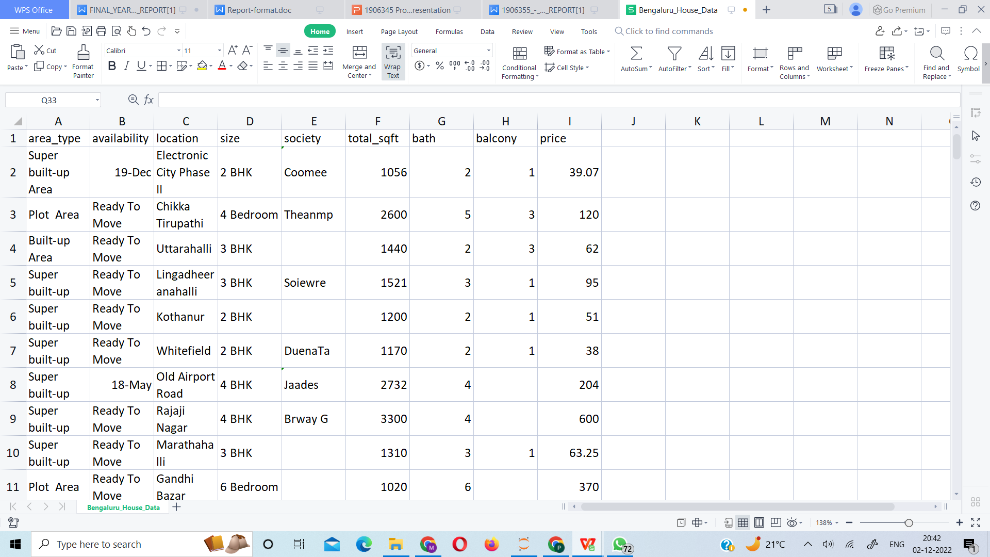

Figure 4.4.1: Dataset

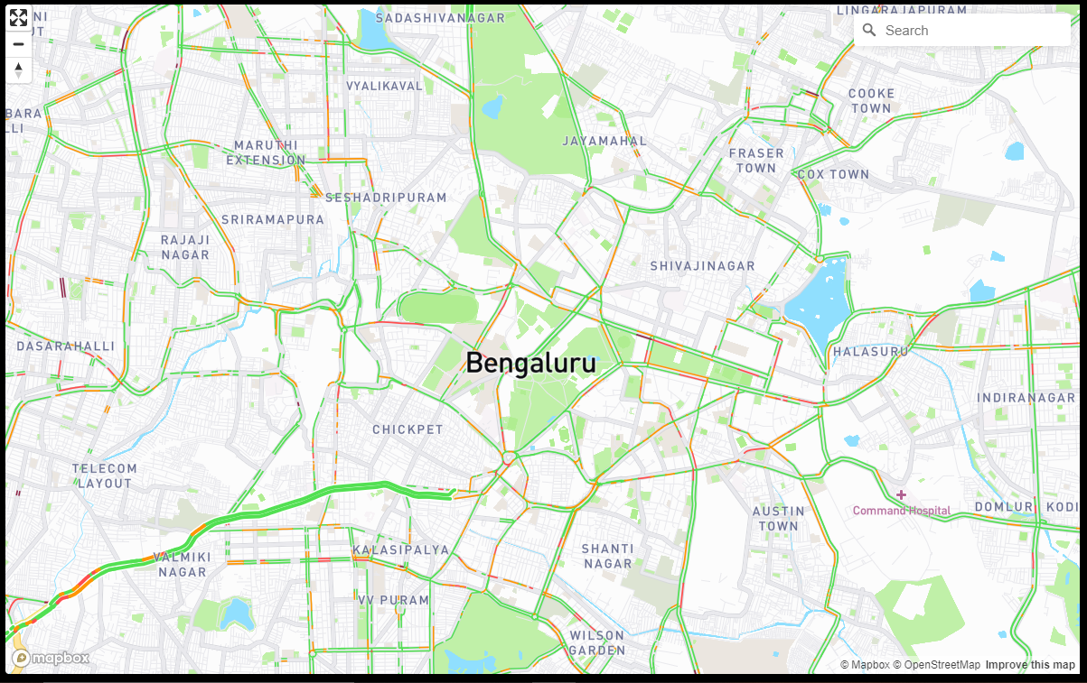

Figure 4.4.2: Map Component

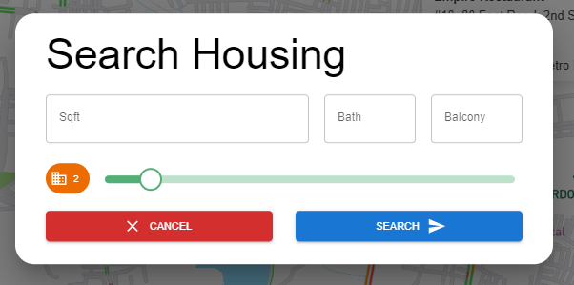

Figure 4.4.3: Modal Form Component

School of Computer Engineering, KIIT, BBSR 5

HOUSEZ

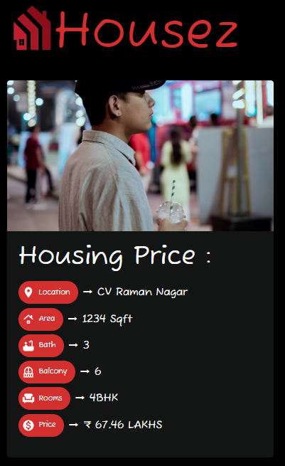

Figure 4.4.4: Meta Data Component

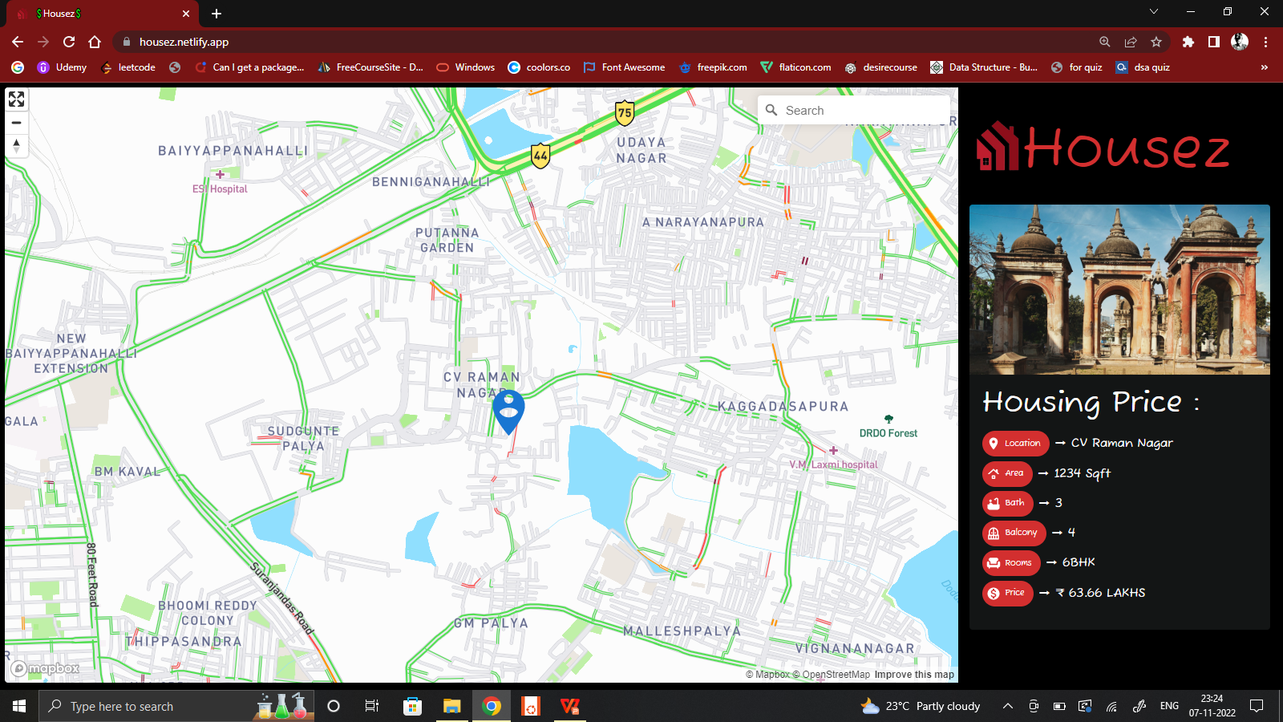

Figure 4.4.5: Final Product

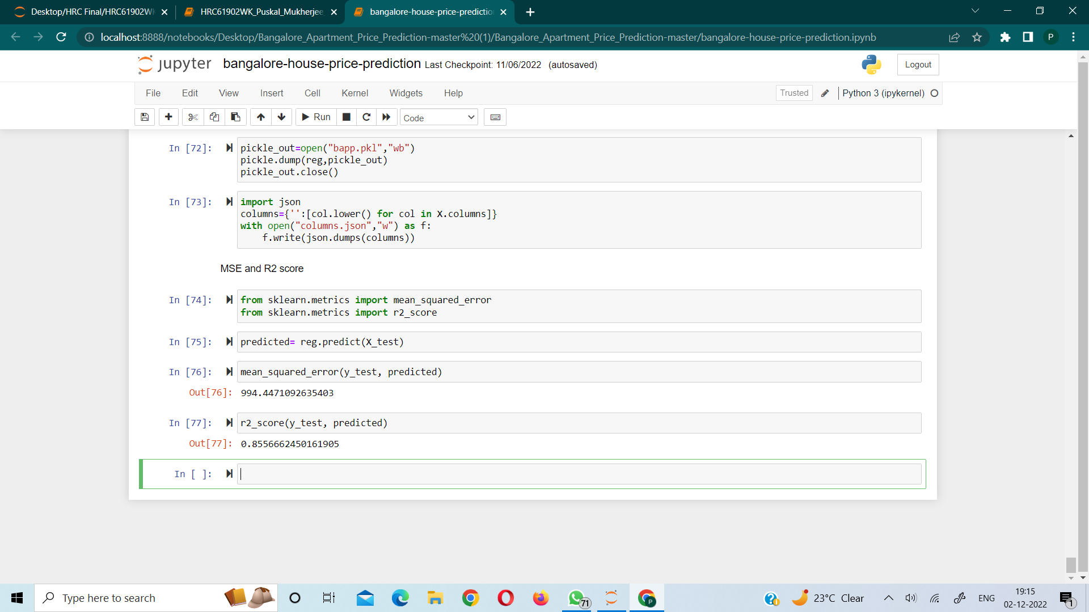

Figure 4.4.6: MSE and R2 Score of the model

School of Computer Engineering, KIIT, BBSR 6

HOUSEZ

Chapter 5

Standards Adopted

5.1 Design Standards
A set of principles for software design:
- The design process should not suffer from “tunnel vision”.
- The design should be traceable to the analysis model.
- The design should not reinvent the wheel.
The design should “minimize the intellectual distance” between the software and the problem in the real world.

5.2 Coding Standards
Coding standards are collections of coding rules, guidelines, and best practices. Few of the coding standards are:-
1.Write as few lines as possible.
2.Use appropriate naming conventions.
3.Segment blocks of code in the same section into paragraphs.
4.Use indentation to marks the beginning and end of control structures. Clearly specify the code between them.
5.Don’t use lengthy functions. Ideally, a single function should carry out a single task.
6.Not making too much data type

School of Computer Engineering, KIIT, BBSR 7

HOUSEZ

Chapter 6

Conclusion & Future Scope

6.1 Conclusion

Getting an estimate of house price in certain areas is painful. All you can get is the individual house prices and decide upon the scattered information. This problem is solved by our project. Moreover it will save a lot of people from getting scammed.

6.2 Future Scope :

Housez has many future scope such as :
- This can be used as consumer & provider platform
- The consumer data can be retrieved & be sold to other services
- Provider data can be used to enhance the ML Model
- Can be converted into community

School of Computer Engineering, KIIT, BBSR 8

HOUSEZ

References

- https://towardsdatascience.com/
- https://mui.com/
- https://www.w3schools.com/react/showreact.asp?filename=demo2_react_test

School of Computer Engineering, KIIT, BBSR 9

HOUSEZ

SAMPLE INDIVIDUAL CONTRIBUTION REPORT:

HOUSEZ

SAIKAT DAS
1906355

Abstract: We propose to implement a house price prediction model of Bangalore, India. It's a Machine Learning model which integrates Data Science and Web Development. We have deployed the ml model instance on Flask & hosted on Render. Housing prices fluctuate on a daily basis and are sometimes exaggerated rather than based on worth.

The major focus of this project is on predicting home prices using genuine factors. Here, we intend to base an evaluation on every basic criterion that is taken into account when establishing the pricing.

The client side is made using React JS & connected to ml-model using axios & hence a full-stack application is created.

Individual contribution and findings: Client Side using React & Material-Ui, which takes parameters from users an estimate the price according to the location & deploying them, resolving the tree file structure & prop-drilling , by passing the data through context-api & optimizing the application.

Individual contribution to project report preparation: This project report, including all the chapters have been done by me, individually.

Individual contribution for project presentation and demonstration: In the presentation, slides of Web App have been made by me. This slides includes Problem Description, Steps involved in building step, about the components, Rest API, Link Layer, Prop Drilling.

Full Signature of Project Mentor: Full signature of the student:
………………… 

School of Computer Engineering, KIIT, BBSR 10

HOUSEZ

PLAGIARISM REPORT
(This report is mandatory for all the projects and plagiarism
must be below 25%)

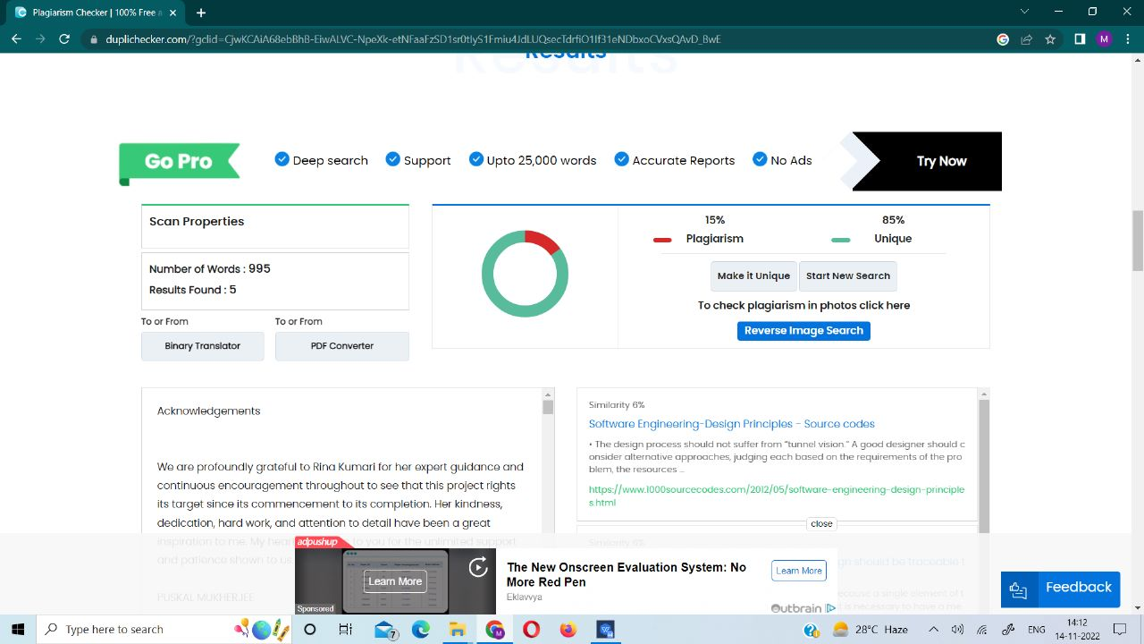

School of Computer Engineering, KIIT, BBSR 11

